LAPORAN TUGAS ALGORITMA DAN PEMROGRAMAN PEKAN 8
PEMROGRAMAN GUI 1
Disusun Oleh:
Khairun Nisa
2511532015
Dosen Pengampu:
DR. WAHYUDI, S.T, M.T
Asisten Pratikum:
Aufan Taufiqurrahman



FAKULTAS TEKNOLOGI INFORMASI
DEPARTEMEN INFORMATIKA
UNIVERSITAS ANDALAS
2025

- Soal
Membuat premrograman GUI operator rasional.

- Pseudocode
Judul
Program operator rasional
{Membuat desan antarmuka menggunakan GUI operator rasional}
Deklarasi
Int Bil1;
Int Bil2;
Boolean hasil= false;
Pseudocode
- Input Bil1
- Input Bil2
- If Bil1 isEmpty, then
- Print Pesan peringatan “Bilangan 1 harus diinput”
- Else if Bil2 isEmpty, then
- Print pesan peringatan “Bilangan 2 harus diinput”
- Else
- Try
- Ambil index operator dari ComboBoox
- If index ==0, then hasil= a1 > a2
- Else if index ==1, then hasil a1<a2
- Else if index == 2, then hasil a1>= a2
- Else if index == 3, then hasil a1<=a2
- Else if index ==4, then hasil a1==a2
- Else if index ==5, then hasil a1!=a2
- Print hasil
- Catch error konversi angka
- Print pesan eror “Bilangan 1 dan Bilangan 2 harus angka”
- End try
- End if
- Flowchart
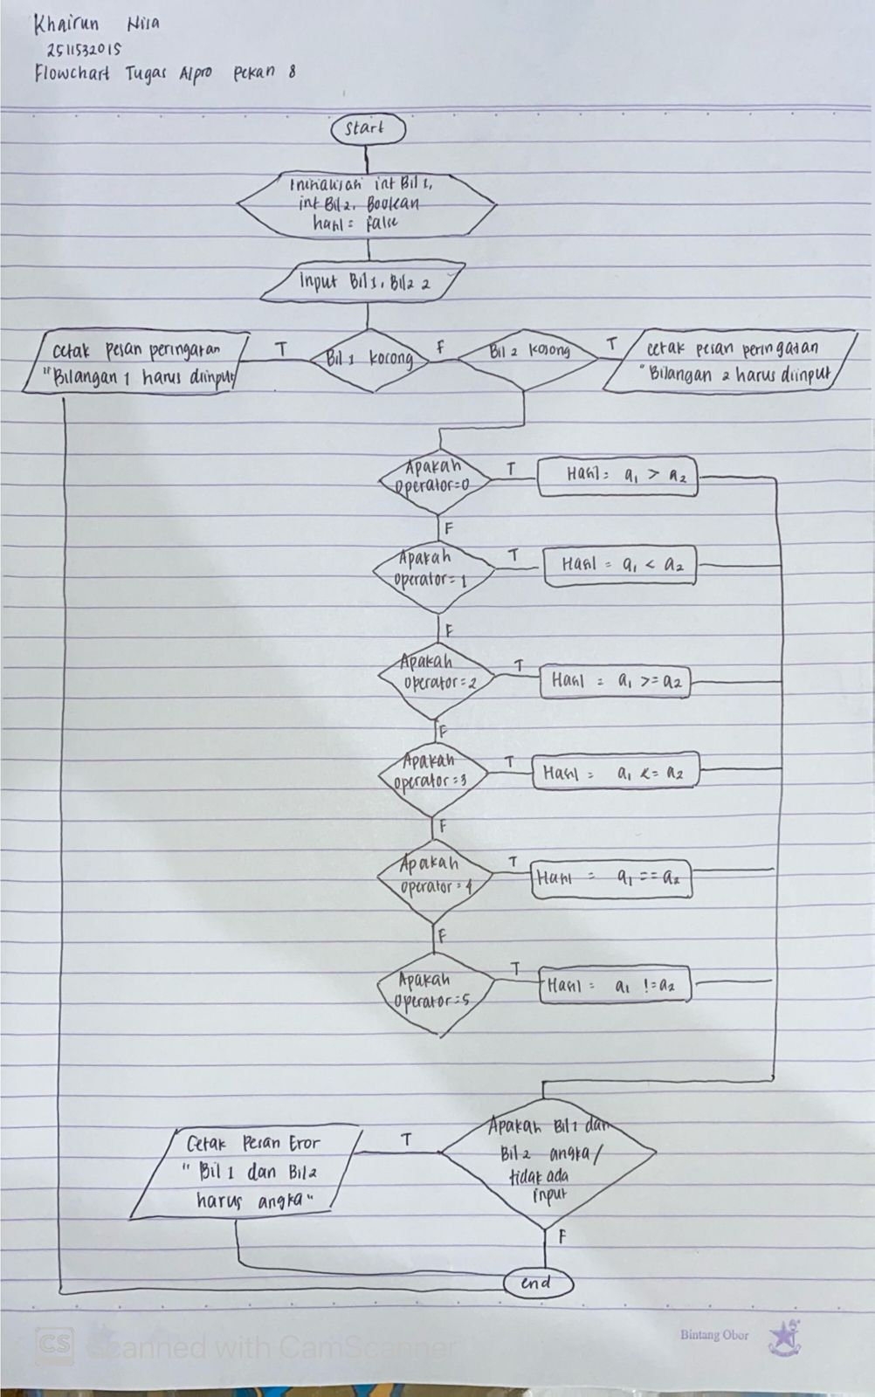

- Source Code
package pekan8_2511532015;

import java.awt.EventQueue;

import javax.swing.JFrame;
import javax.swing.JPanel;
import javax.swing.border.EmptyBorder;
import javax.swing.JLabel;
import javax.swing.JOptionPane;
import javax.swing.SwingConstants;
import javax.swing.JTextField;
import javax.swing.JSpinner;
import javax.swing.SpinnerListModel;
import javax.swing.JButton;
import java.awt.Color;
import javax.swing.JComboBox;
import javax.swing.DefaultComboBoxModel;
import java.awt.event.ActionListener;
import java.awt.event.ActionEvent;
import java.awt.Font;

public class TugasOperatorRasional_2511532015 extends JFrame {

private static final long serialVersionUID = 1L;
private JPanel contentPane;
private JTextField txtBil1;
private JTextField txtBil2;
private JTextField textHasil;

private void pesanPeringatan (String pesan) {
JOptionPane.showMessageDialog(this, pesan,"Peringatan", JOptionPane.WARNING_MESSAGE);
}
private void pesanEror (String pesan) {
JOptionPane.showMessageDialog(this, pesan, "Kesalahan", JOptionPane.ERROR_MESSAGE);
}

/**
* Launch the application.
*/
public static void main(String[] args) {
EventQueue.invokeLater(new Runnable() {
public void run() {
try {
TugasOperatorRasional_2511532015 frame = new TugasOperatorRasional_2511532015();
frame.setVisible(true);
} catch (Exception e) {
e.printStackTrace();
}
}
});
}

/**
* Create the frame.
*/
public TugasOperatorRasional_2511532015() {
setDefaultCloseOperation(JFrame.EXIT_ON_CLOSE);
setBounds(100, 100, 300, 300);
contentPane = new JPanel();
contentPane.setForeground(new Color(210, 193, 217));
contentPane.setBackground(new Color(255, 221, 238));
contentPane.setBorder(new EmptyBorder(5, 5, 5, 5));
setContentPane(contentPane);
contentPane.setLayout(null);

JLabel txtJudul = new JLabel("OPERATOR RASIONAL");
txtJudul.setFont(new Font("Tempus Sans ITC", Font.BOLD, 13));
txtJudul.setHorizontalAlignment(SwingConstants.CENTER);
txtJudul.setBounds(68, 11, 152, 14);
contentPane.add(txtJudul);

JLabel labelBil1 = new JLabel("Bilangan 1");
labelBil1.setFont(new Font("Trebuchet MS", Font.PLAIN, 11));
labelBil1.setBounds(10, 44, 70, 14);
contentPane.add(labelBil1);

JLabel labelBil2 = new JLabel("Bilangan 2");
labelBil2.setFont(new Font("Trebuchet MS", Font.PLAIN, 11));
labelBil2.setBounds(10, 80, 70, 14);
contentPane.add(labelBil2);

txtBil1 = new JTextField();
txtBil1.setHorizontalAlignment(SwingConstants.CENTER);
txtBil1.setBounds(90, 41, 49, 20);
contentPane.add(txtBil1);
txtBil1.setColumns(10);

txtBil2 = new JTextField();
txtBil2.setHorizontalAlignment(SwingConstants.CENTER);
txtBil2.setColumns(10);
txtBil2.setBounds(90, 77, 49, 20);
contentPane.add(txtBil2);

JLabel OperatorRasional = new JLabel("Operator");
OperatorRasional.setFont(new Font("Trebuchet MS", Font.PLAIN, 11));
OperatorRasional.setBounds(10, 130, 70, 14);
contentPane.add(OperatorRasional);

JLabel lblHasil = new JLabel("Hasil");
lblHasil.setFont(new Font("Trebuchet MS", Font.PLAIN, 11));
lblHasil.setBounds(10, 170, 70, 14);
contentPane.add(lblHasil);

textHasil = new JTextField();
textHasil.setForeground(new Color(0, 0, 0));
textHasil.setEditable(false);
textHasil.setHorizontalAlignment(SwingConstants.CENTER);
textHasil.setColumns(10);
textHasil.setBounds(90, 167, 49, 20);
contentPane.add(textHasil);

JComboBox cbOperator = new JComboBox();
cbOperator.setBackground(new Color(255, 255, 255));
cbOperator.setModel(new DefaultComboBoxModel(new String[] {">", "<", ">=", "<=", "==", "!="}));
cbOperator.setBounds(90, 126, 50, 22);
contentPane.add(cbOperator);

JButton Bandingkan = new JButton("Bandingkan");
Bandingkan.setBackground(new Color(255, 106, 181));
Bandingkan.setForeground(new Color(255, 187, 187));
Bandingkan.addActionListener(new ActionListener() {
public void actionPerformed(ActionEvent e) {
if (txtBil1.getText().trim().isEmpty()) {
pesanPeringatan ("Bilangan 1 harus diinput");
} else if (txtBil2.getText().trim().isEmpty()) {
pesanPeringatan ("Bilangan 2 harus diinput");
} else {
try {
int a1= Integer.valueOf(txtBil1.getText().trim());
int a2= Integer.valueOf(txtBil2.getText().trim());
int operator= cbOperator.getSelectedIndex();
boolean hasil= false;

switch (operator) {
case 0:
hasil= a1 > a2;
break;
case 1:
hasil= a1 < a2;
break;
case 2:
hasil= a1 <= a2;
break;
case 3:
hasil= a1 <= a2;
break;
case 4:
hasil= a1 == a2;
break;
case 5:
hasil= a1 != a2;
break;
}

textHasil.setText(String.valueOf(hasil));
} catch (NumberFormatException ex) {
pesanEror ("Bilangan 2 dan Bilangan 2 harus angka");
}
}
}
});
Bandingkan.setBounds(157, 126, 119, 22);
contentPane.add(Bandingkan);

}
}
- Penjelasan Singkat
Program ini adalah aplikasi desktop sederhana yang membandingkan dua bilangan bulat menggunakan operator Rasional. Pengguna memasukkan dua angka, memilih operator lalu mengklik “Bandingkan”. Program akan memeriksa apakah inputnya valid, kalua misal kosong atau bukan angka maka akan muncul pesan peringatan.
Jika inputan benar, program membandingkan kedua angka sesuai dengan operator ynag dipilih, jika perbandingannya benar maka akan mucul true di kolom hasil, sebaliknya akan muncul false.

